DIOCESAN COUNCIL MINUTES

DIOCESE OF THE WEST
  - October 17, 2019
His Eminence, Archbishop Benjamin convened a special meeting of the Diocesan Council at Glen Eyrie, Colorado, on Thursday, October 17, 2019, at the conclusion of the 2019 Diocesan Assembly.
ABP. BENJAMIN proposed 2020 Diocesan Meetings to Council Members Archpriest Basil Rhodes, Archpriest John Dresko, Archpriest Lawrence Russell, Archpriest John Pierce, Archpriest Matthew Tate, Archpriest Stephen Soot, Archpriest Lawrence Margitich, Archpriest Anthony Karbo, Archpriest Michael Anderson, Archpriest Damian Kuolt, Priest Andrew Cuneo, Subdeacon Paul Pilipenko, Matushka Theodora Blom, Dorothy Nowik, Lynnell Brunswig, Carrie Guy:
- The next Diocesan Assembly will be held Tuesday, October 13th-15th, 2020 in Las Vegas
- The next meeting of the Diocesan Advisory/Council meetings will be held in January 14-15th
The proposed meetings were accepted by the Diocesan Council by common ascent
ADJOURNMENT – Abp. Benjamin adjourned the meeting of the Diocesan Council at the conclusion of this single item of business.

Submitted by:
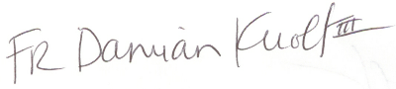
Archpriest Damian Kuolt, Secretary

